ROHM Switching Regulator Solutions

Evaluation Board:

Synchronous Buck Converter

Integrated FET

BD9G341EFJ-E2EVK-101 (5V | 3A Output)

No.000000000

* Introduction

This application note will provide the steps necessary to operate and evaluate ROHM’s synchronous buck DC/DC converter using the BD9G341EFJ evaluation boards. Component selection, board layout recommendations, operation procedures and application data is provided.

* Description

This evaluation board has been developed for ROHM’s synchronous buck DC/DC converter customers evaluating BD9G341EFJ. While accepting a power supply of 12V to 76V, an output of 5V can be produced. The IC has internal 150mΩ N-channel MOSFET and the operating frequency is programmable from 50kHz to 750kHz. A fixed Soft Start circuit prevents inrush current during startup along with UVLO (low voltage error prevention circuit) and TSD (thermal shutdown detection), OCP (over current protection), OVP (over voltage protection) protection circuits. An EN pin allows for simple ON/OFF control of the IC to reduce standby current consumption.

* Applications

Industrial distributed power applications.

Automotive application.

Battery powered equipment.

* Evaluation Board Operating Limits and Absolute Maximum Ratings

|  |  |  |  |  |  |  |  |
| --- | --- | --- | --- | --- | --- | --- | --- |
| **Parameter** | | **Symbol** | **Limit** | | | **Unit** | **Conditions** |
| **MIN** | **TYP** | **MAX** |
| **Supply Voltage** | | | | | | | |
|  | BD9G341EFJ | VCC | 12 | - | 76 | V |  |
| **Output Voltage / Current** | | | | | | | |
|  | BD9G341EFJ | VOUT | - | 5 | - | V |  |
| IOUT | - | - | 3 | A |  |

* Evaluation Board

Below is evaluation board with the BD9G341EFJ.

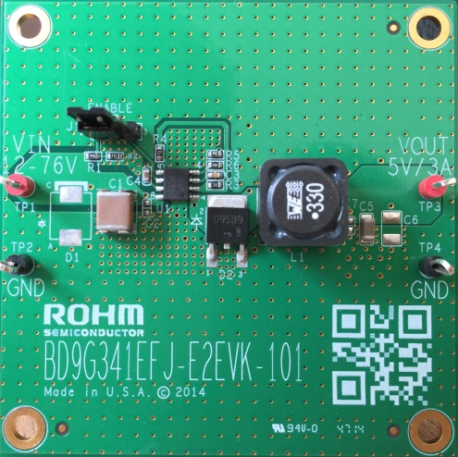

Fig 1: BD9G341EFJ Evaluation Board

* Evaluation Board Schematic

**Vout**

**GND**

**EN**

BD9673EFJ Eval Board

Below is evaluation board schematic for BD9G341EFJ.

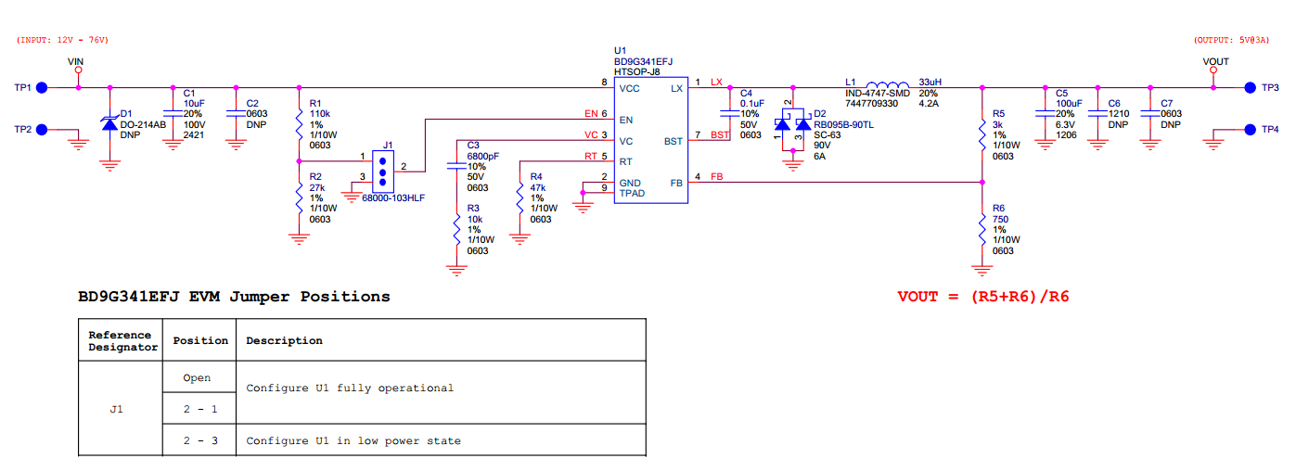

Fig 2: BD9G341EFJ Evaluation Board Schematic

* Evaluation Board I/O

Below is reference application circuit that shows the inputs (VIN and EN) and the output (VOUT).

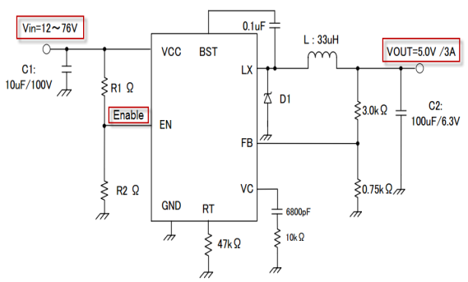

Fig 3: BD9G341EFJ Evaluation Board I/O

* Evaluation Board Operation Procedures

Below is the procedure to operate the evaluation board.

1. Connect power supply’s GND terminal to GND test point TP2 on the evaluation board.
2. Connect power supply’s VCC terminal to VIN test point TP1 on the evaluation board. This will provide VIN to the IC U1. Please note that the VCC should be in range of 12V to 76V.
3. Check if shunt jumper of J1 is at position ON (Pin2 connect to Pin1, EN pin of IC U1 is pulled high).
4. Connect electronic load to TP3 and TP4. Do not turn on load (electronic load is off power).
5. Turn on power supply. The output voltage VOUT(+5V) can be measured at the test point TP3. Now turn on the load. The load can be increased up to 3A MAX.

*Notes*:

*The board does not support hot plugging protection. Do not perform hot plugging on this board.*

* Reference Application Data for BD9G341EFJ-E2EVK-101

Following graphs show quiescent current, efficiency, load response, output voltage ripple response of the BD9G341EFJ evaluation board.

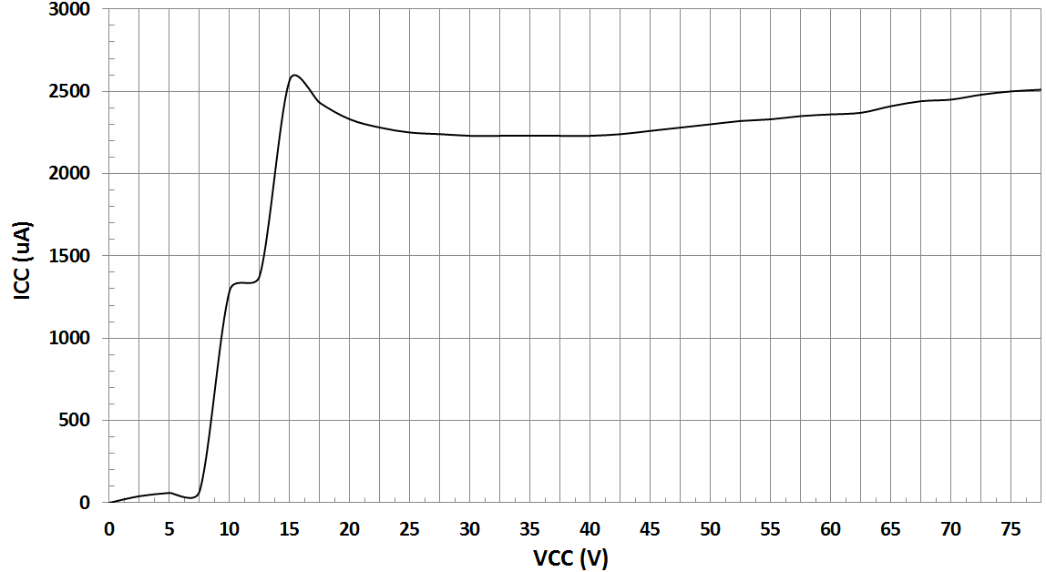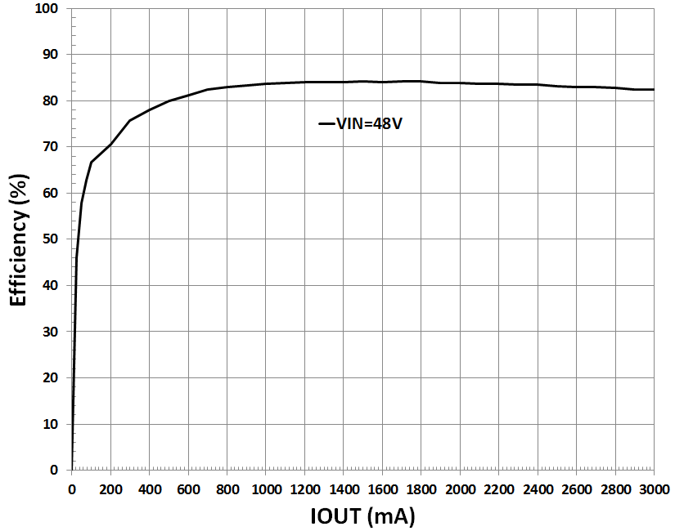

**Fig 4: Circuit Current vs. Power supply Voltage Characteristics (Temp=25oC)**

**Fig 5: Electric Power Conversion Rate**

**(VIN=48V, VOUT=5V)**

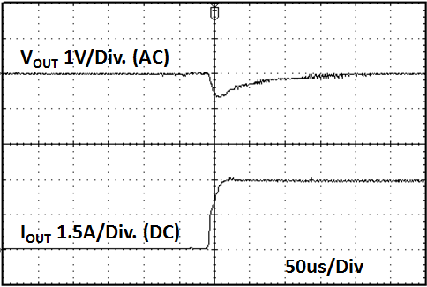 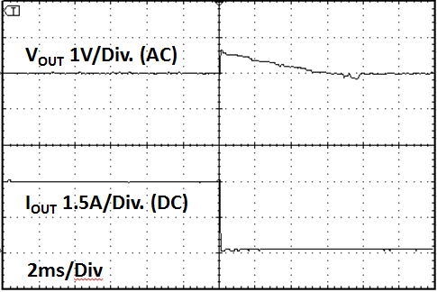

Fig 6: Load Response Characteristics

(VIN=48V, VOUT=5V, IOUT=0🡪3A)

Fig 7: Load Response Characteristics

(VIN=48V, VOUT=5V, IOUT=3A🡪0A)

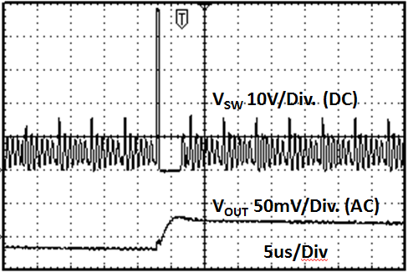 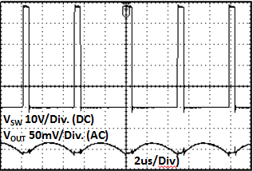

Fig 8: Output Voltage Ripple Response Characteristics

(VIN=48V, VOUT=5V, IOUT=0A)

Fig 9: Output Voltage Ripple Response Characteristics

(VIN=48V, VOUT=5V, IOUT=3A)

* Evaluation Board Layout Guidelines

Layout is a critical portion of good power supply design. There are several signals paths that conduct fast changing currents

or voltages that can interact with stray inductance or parasitic capacitance to generate noise or degrade the power supplies

performance. To help eliminate these problems, the VCC pin should be bypassed to ground with a low ESR ceramic bypass

capacitor with B dielectric. Care should be taken to minimize the loop area formed by the bypass capacitor connections, the

VCC pin, and the anode of the catch diode. The GND pin should be tied directly to the thermal pad under the IC and the thermal pad. In order to reduce the influence of the impedance and L of the parasitic, the high current line is thick and short.

Input decoupling capacitor should be located as close to the VCC pins.

In order to minimize the parasitic capacitor and impedance of pattern, catch diode and inductance should be located as

close to the Lx pin.

The thermal pad should be connected to any internal PCB ground planes using multiple VIAs directly under the IC.

GND feedback resistor, phase compensation element and RT resistor don’t give the common impedance resistor against

high current line…

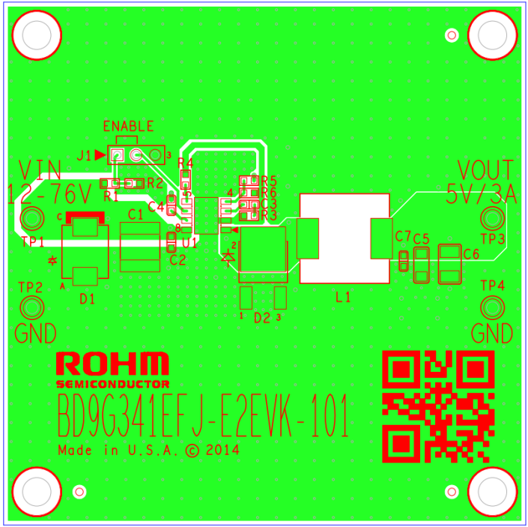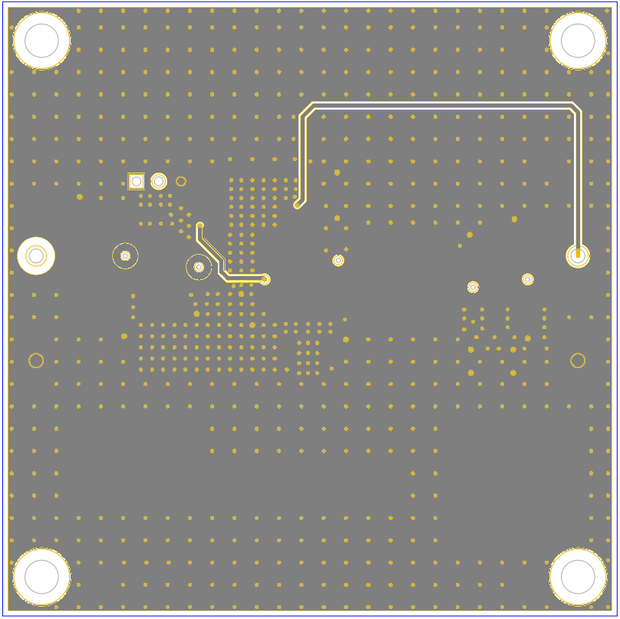

Top Layer

Bottom Layer

Fig 10: BD9G341EFJ-E2EVK-101 Board PCB layout

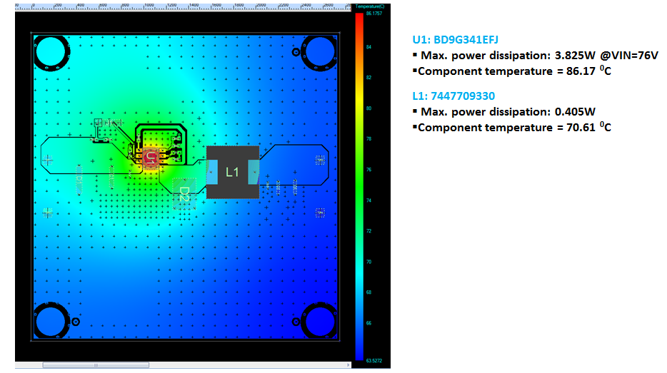

Fig 11: BD9G341EFJ-E2EVK-101 Thermal Characteristics at Temp=25oC, No air flow, VIN=76V, VOUT=5V, IOUT=3A

Thermal note: If the board is operated above room temperature (T>25oC), an active cooling source (fan) or heat sink (soldered to bottom of PCB) need to be added.

Additional layout notes:

* The thermal Pad on the back side of IC has the great thermal conduction to the chip. So using the GND plane as broad and wide as possible can help thermal dissipation. And a lot of thermal via for helping the spread of heat to the different layer is also effective.
* The input capacitors should be connected to GND as close as possible to the VIN terminal.
* The inductor and the output capacitors should be placed close to SW pin as much as possible.
* For applications operating at or near maximum voltage conditions (76V max), additional precautions regarding heat dissipation need to be considered during board layout. The provided evaluation board is a 4-layer board meant for evaluation purposes only. At maximum conditions, the IC’s internal thermal shutdown detection circuit will be potentially initiated and the output disabled until the junction temperature falls. For final designs operating near these conditions, we recommend using one of the below PCB options for better heat dissipation of the IC.

1. Use of a 4-layer PCB with internal GND planes connected to the IC GND pins.
2. Use of a 2-layer PCB with a heat sink attached to the IC package.
3. Use of a 2-layer PCB with a copper plane (>1oz) attached to the IC.

* Calculation of Application Circuit Components

1. Inductors

Something of the shield type that fulfills the current rating (Current value Ipeak below), with low DCR is recommended.

Value of Inductance influences Inductor Ripple Current and becomes the cause of Output Ripple.

In the same way as the formula below, this Ripple Current can be made small for as big as the L value of Coil or as high as the Switching Frequency.

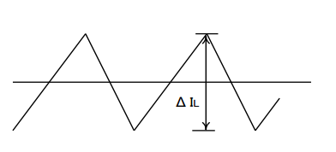

Fig 12: Inductor Current

(∆IL: Output Ripple Current, VCC: Input Voltage, VOUT: Output Voltage, f: Switching Frequency)

For design value of Inductor Ripple Current, please carry out design tentatively with about 20%～50% of Maximum Input Current.

In the BD9G341EFJ, it is recommended the below series of 4.7μH～33μH inductance value.

Recommended Inductor：SUMIDA CDRH127H Series

1. Output Capacitor

In order for capacitor to be used in output to reduce output ripple, Low ceramic capacitor of ESR is recommended.

Also, for capacitor rating, on top of putting into consideration DC Bias characteristics, please use something whose maximum rating has sufficient margin with respect to the Output Voltage.

Output ripple voltage is looked for using the following formula.

Please design in a way that it is held within Capacity Ripple Voltage.

In the BD9G341EFJ, it is recommended a ceramic capacitor over 10μF.

1. Output voltage setting

The internal reference voltage of ERROR AMP is 1.0V.

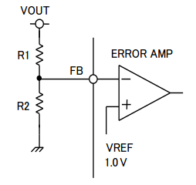

Fig 13: Output voltage setting

Output voltage is determined like (4) types

1. Bootstrap Capacitor

Please connect from 0.1uF (Laminate Ceramic Capacitor) between BST Pin and Lx Pins.

1. Catch Diode

BD9G341EFJ should be taken to connect external catch diode between Lx Pin and GND Pin. The diode require adherence to absolute maximum Ratings of application. Opposite direction voltage should be higher than maximum voltage of Lx Pin (VCCMAX + 0.5V). The peak current is required to be higher than IOUTMAX +∆IL.

1. Input Capacitor

BD9G341EFJ needs an input decoupling capacitor. It is recommended a low ceramic capacitor ESR over 4.7μF . Additionally, it should be located as close as possible.

Capacitor should be selected by maximum input voltage with input ripple voltage.

Input ripple voltage is calculated by using the following formula.

CVCC: Input capacitor

RMS ripple current is calculated by using the following formula.

If VCC=2VOUT, RMS ripple current is maximum. That is determined by (9) .

1. About Adjustment of DC/DC Comparator Frequency Characteristics

Role of Phase compensation element C1, C2, R3.

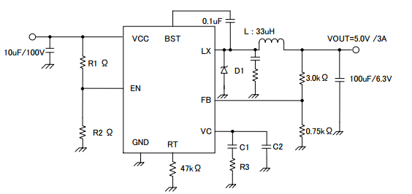

Fig 14: Feedback voltage resistance setting method

Stability and Responsiveness of Loop are controlled through VC Pin which is the output of Error Amp.

The combination of zero and pole that determines Stability and Responsiveness is adjusted by the combination of resistor and capacitor that are connected in series to the VC Pin.

DC Gain of Voltage Return Loop can be calculated for using the following formula.

Here, VFB is Feedback Voltage (1.0V).AEA is Voltage Gain of Error amplifier (typ: 55.6dB), Gcs is the Trans-conductance of Current Detect (typ: 10A/V), and Rl is the Output Load Resistance value.

There are 2 important poles in the Control Loop of this DC/DC.

The first occurs with/ through the output resistance of Phase compensation Capacitor (C1) and Error amplifier.

The other one occurs with/through the Output Capacitor and Load Resistor.

These poles appear in the frequency written below.

Here, GEA is the trans-conductance of Error amplifier (typ: 300 µA/V).

Here, in this Control Loop, one zero becomes important. With the zero which occurs because of Phase compensation Capacitor C1 and Phase compensation Resistor R3, the Frequency below appears.

Also, if Output Capacitor is big, and that ESR (RESR) is big, in this Control Loop, there are cases when it has an important, separate zero (ESR zero).

This ESR zero occurs due to ESR of Output Capacitor and Capacitance, and exists in the Frequency below.

(ESR zero)

In this case, the 3rd pole determined with the 2nd Phase compensation Capacitor (C2) and Phase Correction Resistor (R3) is used in order to correct the ESR zero results in Loop Gain.

This pole exists in the frequency shown below.

(pole that corrects ESR zero)

The target of Phase compensation design is to create a communication function in order to acquire necessary band and Phase margin.

Cross-over Frequency (band) at which Loop gain of Return Loop becomes “0” is important.

When Cross-over Frequency becomes low, Power supply Fluctuation Response, Load Response, etc worsens.

On the other hand, when Cross-over Frequency is too high, instability of the Loop can occur.

Tentatively, Cross-over Frequency is targeted to be made 1/20 or below of Switching Frequency.

Selection method of Phase Compensation constant is shown below.

1. Phase Compensation Resistor (R3) is selected in order to set to the desired Cross-over Frequency.

Calculation of RC is done using the formula below.

Here, fc is the desired Cross-over Frequency. It is made about 1/20 and below of the Normal Switching Frequency (fs).

1. Phase compensation Capacitor (C1) is selected in order to achieve the desired phase margin.

In an application that has a representative Inductance value (about several 3.3µH～10µH), by matching zero of

compensation to 1/4 and below of the Cross-over Frequency, sufficient Phase margin can be acquired. C1 can be

calculated using the following formula.

1. Examination whether the second Phase compensation Capacitor C2 is necessary or not is done.

If the ESR zero of Output Capacitor exists in a place that is smaller than half of the Switching Frequency, a second Phase compensation Capacitor is necessary. In other words, it is the case wherein the formula below happens.

In this case, add the second Phase compensation Capacitor C2, and match the frequency of the third pole to the Frequency fp3 of ESR zero.

* Evaluation Board BOM

Below is a table with the build of materials. Part numbers and supplier references are provided.

|  |  |  |  |  |  |
| --- | --- | --- | --- | --- | --- |
| **Item** | **Qty.** | **Ref** | **Description** | **Manufacturer** | **Part Number** |
| 1 | 1 | C1 | CAP CER 10UF 100V 20% X7R SMD | Murata Electronics North America | KRM55TR72A106MH01K |
| 2 | 1 | C3 | CAP CER 6800PF 50V 10% X7R 0603 | Murata Electronics North America | GRM188R71H682KA01D |
| 3 | 1 | C4 | CAP CER 0.1UF 50V 10% X7R 0603 | Murata Electronics North America | GRM188R71H104KA93D |
| 4 | 1 | C5 | CAP CER 100UF 6.3V 20% X5R 1206 | Murata Electronics North America | GRM31CR60J107ME39L |
| 5 | 1 | D2 | DIODE SCHOTTKY 90V 3A CPD | Rohm | RB095B-90TL |
| 6 | 1 | J1 | CONN HEADER VERT .100 3POS 15AU | FCI | 68000-103HLF |
| 7 | 1 | L1 | INDUCTOR POWER 33UH 4.2A SMD | Wurth Electronics Inc | 7447709330 |
| 8 | 1 | R1 | RES 110K OHM 1/10W 1% 0603 SMD | Rohm | MCR03ERTF1103 |
| 9 | 1 | R2 | RES 27K OHM 1/10W 1% 0603 SMD | Rohm | MCR03ERTF2702 |
| 10 | 1 | R3 | RES 10K OHM 1/10W 1% 0603 SMD | Rohm | MCR03ERTF1002 |
| 11 | 1 | R4 | RES 47K OHM 1/10W 1% 0603 SMD | Rohm | MCR03ERTF4702 |
| 12 | 1 | R5 | RES 3K OHM 1/10W 1% 0603 SMD | Rohm | MCR03ERTF3001 |
| 13 | 1 | R6 | RES 750 OHM 1/10W 1% 0603 SMD | Rohm | MCR03ERTF7500 |
| 14 | 2 | TP1,TP3 | TEST POINT PC MULTI PURPOSE RED | Keystone Electronics | 5010 |
| 15 | 2 | TP2,TP4 | TEST POINT PC MULTI PURPOSE BLK | Keystone Electronics | 5011 |
| 16 | 1 | U1 | IC REG BUCK SYNC ADJ 3A HTSOP-J8 | Rohm | BD9G341EFJ-E2 |

**Notes**

No copying or reproduction of this document, in part or in whole, is permitted without the consent of ROHM Co.,Ltd.

The content specified herein is subject to change for improvement without notice.

The content specified herein is for the purpose of introducing ROHM's products (hereinafter"Products"). If you wish to use any such Product, please be sure to refer to the specifications,which can be obtained from ROHM upon request.

Examples of application circuits, circuit constants and any other information contained hereinillustrate the standard usage and operations of the Products. The peripheral conditions mustbe taken into account when designing circuits for mass production.

Great care was taken in ensuring the accuracy of the information specified in this document.However, should you incur any damage arising from any inaccuracy or misprint of suchinformation, ROHM shall bear no responsibility for such damage.

The technical information specified herein is intended only to show the typical functions of andexamples of application circuits for the Products. ROHM does not grant you, explicitly orimplicitly, any license to use or exercise intellectual property or other rights held by ROHM andother parties. ROHM shall bear no responsibility whatsoever for any dispute arising from theuse of such technical information.

The Products specified in this document are intended to be used with general-use electronicequipment or devices (such as audio visual equipment, office-automation equipment, communicationdevices, electronic appliances and amusement devices).

The Products specified in this document are not designed to be radiation tolerant.

While ROHM always makes efforts to enhance the quality and reliability of its Products, aProduct may fail or malfunction for a variety of reasons.

Please be sure to implement in your equipment using the Products safety measures to guardagainst the possibility of physical injury, fire or any other damage caused in the event of thefailure of any Product, such as derating, redundancy, fire control and fail-safe designs. ROHMshall bear no responsibility whatsoever for your use of any Product outside of the prescribedscope or not in accordance with the instruction manual.

The Products are not designed or manufactured to be used with any equipment, device orsystem which requires an extremely high level of reliability the failure or malfunction of whichmay result in a direct threat to human life or create a risk of human injury (such as a medicalinstrument, transportation equipment, aerospace machinery, nuclear-reactor controller, fuel-controlleror other safety device). ROHM shall bear no responsibility in any way for use of anyof the Products for the above special purposes. If a Product is intended to be used for anysuch special purpose, please contact a ROHM sales representative before purchasing.

If you intend to export or ship overseas any Product or technology specified herein that maybe controlled under the Foreign Exchange and the Foreign Trade Law, you will be required toobtain a license or permit under the Law.



Thank you for your accessing to ROHM product information.

More detail product information and catalogs are available, please contact us.

**ROHM Customer Support System**

<http://www.rohm.com/contact/>